Ultraconserved non-coding DNA within insect phyla

Thomas Brody^{1*} Amar Yavatkar², Alexander Kuzin¹ and Ward F. Odenwald^{1*}

¹Neural Cell-Fate Determinants Section,
²Division of Intramural Research, Information Technology Program,
NINDS, NIH, Bethesda, Maryland, USA

Running title: Ultraconserved sequences in insect enhancers

*Corresponding authors: Tel: 301-496-1657, E-mail: brodyt@ninds.nih.gov, odenwaldw@ninds.nih.gov

ADDITIONAL FILE 1

Supplemental Table 1: Ant and Bee species formatted for EvoPrint analysis

Bee species (superfamily Apoidea) | Ant species (superfamily Formicoidea)
Apidae – social bees  Apis mellifera - Western honey bee  Apis dorsata - Giant honey bee  Apis florea - Dwarf honey bee  Bombus terrestrialis - Buff-tailed bumblebee  Bombus impatiens - Common eastern bumblebee  Habropoda laboriosa - Southeastern blueberry bee  Megachilidae  Megachile rotundata - alfalfa leafcutter bee – solitary | Myrmicinae –  Atta cephalotes – Leafcutter ant  Acromyrmex echinatior – Panama leaf-cutting ant  Wasmannia auropunctata - Little fire ant  Pogonomyrmex barbatus - Red harvester ant  Monomorium pharaonis - Pharaoh ant  Solenopsis invicta – Red fire ant  Vollenhovia emeryi – Japanese ant  Cardiocondyla obscurior – a tramp ant  Formicinae  Lasius niger - Black garden ant  Ooceraea biroi - Army ant – colonial raider ant  Camponotus floridanus - Florida carpenter ants  Ponerinae  Harpegnathos saltator - Jerdon's jumping ant  Dolichoderinae  Linepithema humile - Argentine Ant

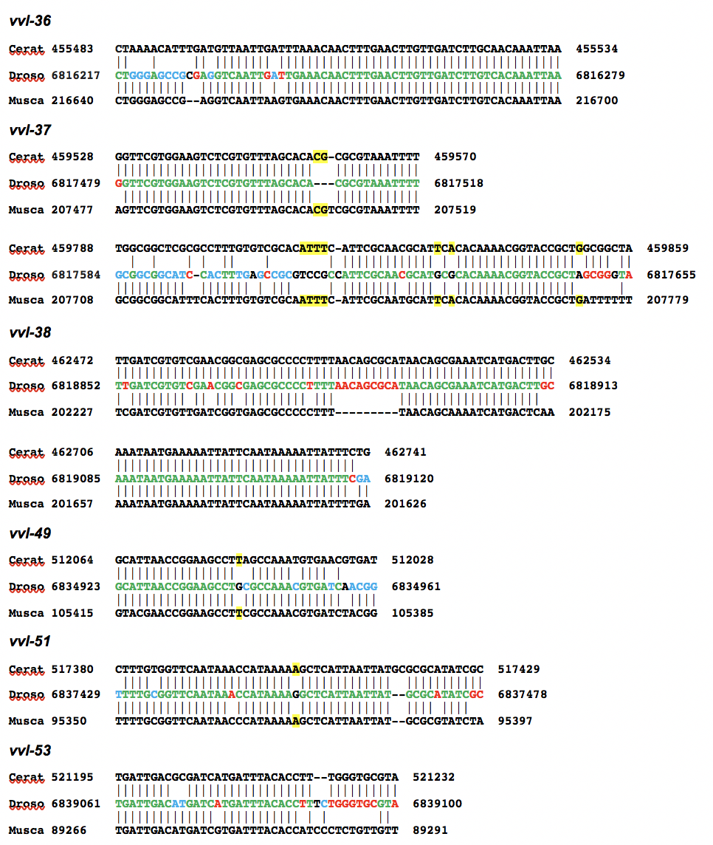
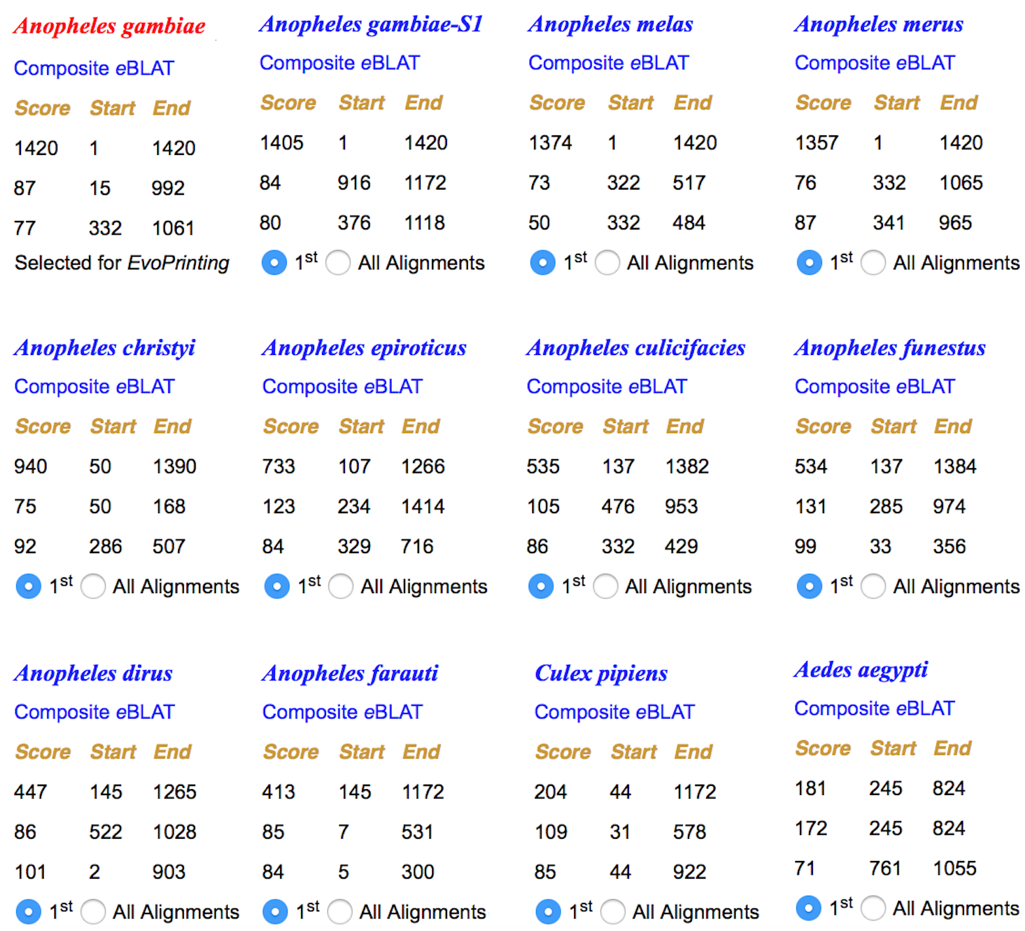
Supplemental Figure 1

Supplemental Figure 2
Supplemental Figure 3
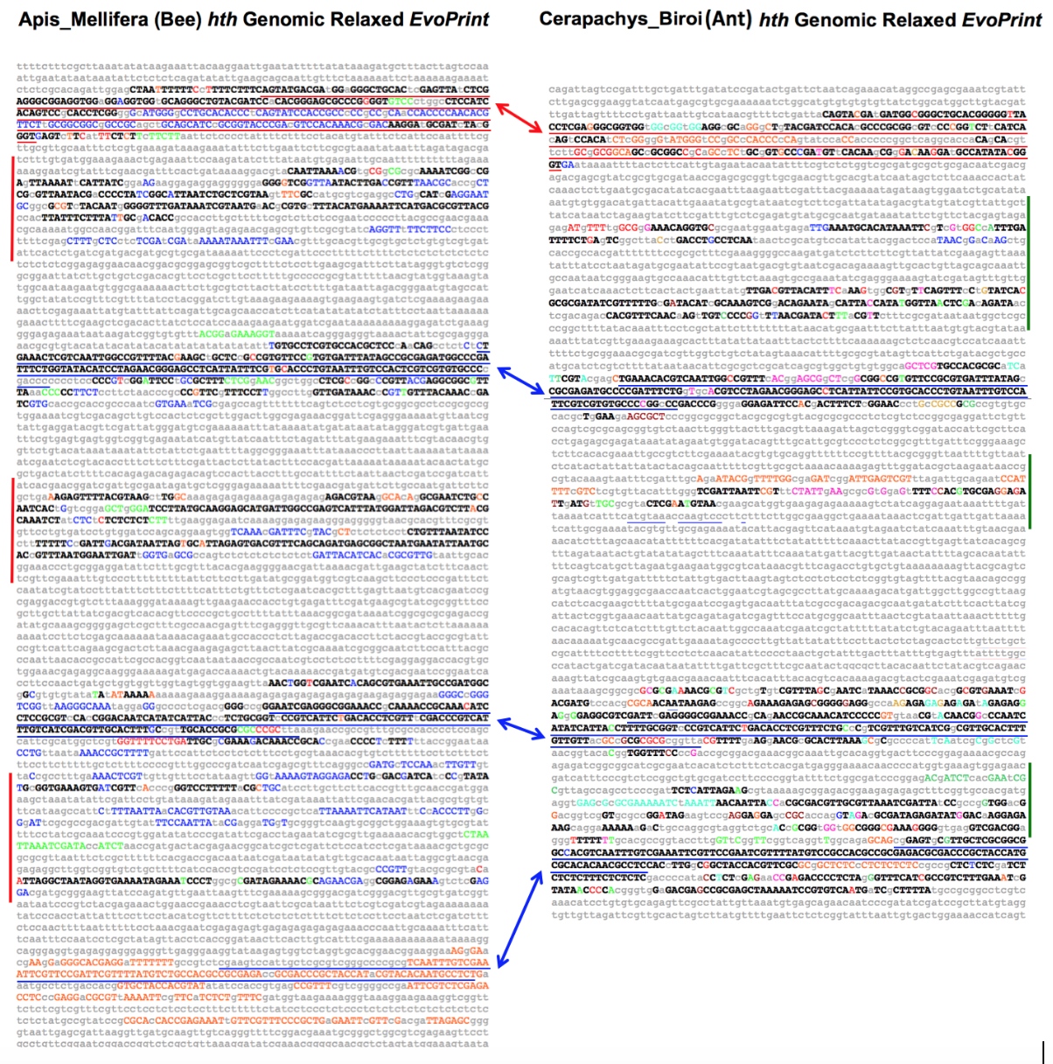

Supplemental Figure 1. Ultra-conserved DNA in Drosophila vvl enhancers identified in Ceratitis capitata and Musca domestica orthologous DNAs.

Three-way Ceratitis-Drosophila-Musca BLASTn alignments of CSBs within six different in vivo tested Drosophila vvl enhancers. Drosophila sequences that are shared with Ceratitis and Musca are shown in green. Red bases are shared only between Drosophila and Ceratitis and blue text represent bases shared exclusively between Drosophila and Musca. Yellow highlighted Ceratitis and Musca bases are not shared in Drosophila. Flanking BLASTn designator numbers indicate genomic base positions.

Supplemental Figure 2. Conservation within the mosquito wingless gene second intron.

EvoPrinter analysis reveals Anopheles gambiae non-coding sequence elements located between the mosquito homologs of Drosophila wg and wnt4 that are conserved in other mosquito species. Alignment data generated from one-on-one comparisons of a 1420 base sequence from the A. gambiae genome. For each species, the top three independent eBLAT alignment scores are listed. Scores indicate the total number of bases within the reference sequence that align with the test species genome. In this analysis, 11 of the 19 mosquito test species present in the database are illustrated. The test species are listed (L -> R) based on their highest alignment score in descending order. Website links to individual eBLAT alignments and superimposed composite eBLATs are indicated in either red or blue font colors. As indicated in the alignment scorecard by the blue selection buttons, the top (highest scoring alignment) for each test species has been selected for EvoPrinting.
Supplemental Figure 3. Side-by-side comparison of conserved sequences within ant and bee homothorax loci identifies shared exon/intron architecture and species-specific conserved sequences.

EvoPrints of bee and ant genomic DNA that includes homothorax (hth) encoding an exon isologous to the 2nd exon of Drosophila hth plus flanking intronic sequences. Blue and red underlined regions are coding and non-coding sequences, respectively, and align with homologous regions in the two panels. Black uppercase bases are conserved in all test species and colored uppercase bases are conserved in all but one of four bee tests species in panel A and all but one of three ant test species in panel B. A) Relaxed EvoPrint of Apis mellifera genomic sequences (6.3kb; Group5:7,111,526-7,117,900). Vertical red bars flanking the EvoPrint indicate conserved bee-specific sequences that are not found in ants. Colored uppercase bases are conserved in all but one of the color-coded test species: Apis florea, Habropoda laboriosa, Bombus terrestrialis and Bombus impatiens. B) Relaxed EvoPrint of Cerapachys biroi genomic DNA (5.1kb; 6532628-6527517, Ooceraea biroi isolate clonal line C1 chromosome 14, Obir_v5.4). The green vertical bar flanking the EvoPrint indicates ant-specific conserved sequence that in absent in bees. Black uppercase bases are conserved in all test ant species and colored uppercase bases are conserved in all but one of the color-coded test species: Monomorium pharaonis, Atta cephalotes, Vollenhovia emeryi, Acromyrmex echinatior, Lasius niger, Pogonomyrmex barbatus, Wasmannia auropunctata, Cardiocondyla obscurior or Linepithema humile.

